PROJECT REPORT OF INDUSTRY ORIENTED HANDS-ON EXPERIENCE (IOHE)
ON
<Expense Management>
submitted in partial fulfilment of the requirements for the award of degree of

BACHELOR OF ENGINEERING
In
COMPUTER SCIENCE AND ENGINEERING

Submitted by: Supervised By:
<Saket Bansal > < Dr. Gurpreet Singh>
<2210992217> < Assistant Professor>
< Department of CSE>


DEPARTMENT OF COMPUTER SCIENCE AND ENGINEERING

CHITKARA UNIVERSITY INSTITUTE OF ENGINEERING AND TECHNOLOGY
CHITKARA UNIVERSITY, PUNJAB, INDIA

CONTENTS

S.No. | Title | Page No.
 | Acknowledgement | iv
 | List of Figures and Tables | v
 | Abstract
1 | Introduction | 1
2 | Methodology
3 | Tools and Technologies
4 | Implementation
5 | Major Findings/Outcomes/Output/Results
6 | Conclusion and Future Scope
 | References
 | Appendices

DECLARATION

I hereby certify that the work which is being presented in the project report entitled “Expense Management” in partial fulfilment of requirement for the award of the degree of Bachelor of Engineering (Computer Science and Engineering) submitted in the department of Computer Science and Engineering at Chitkara University Institute of Engineering and Technology, Chitkara University, Punjab, India, is an authentic record of my own work carried out under the supervision of Dr. Gurpreet Singh. The matter presented in this project report has not been submitted in any other university/institute for the award of any degree.

Place: Rajpura (Saket Bansal)
Date: …………….. (University Roll No: 2210992217)

This is to certify that the above statement made by the candidate is correct to the best of my knowledge and belief.

(Dr. Gurpreet Singh)
Assistant Professor
Department of Computer Science and Engineering
Chitkara University Institute of Engineering and Technology,
Chitkara University, Punjab, India

ACKNOWLEDGEMENT
Through this acknowledgement, I express our sincere gratitude to all those people who have been associated with this project and have helped me with it and made it a worthwhile experience. First and foremost, I would like to thank Solitaire Infosys for giving me courage to make this project. At the outset, I would like to propose a word of thanks for the people who gave me unending support and help in numerous ways.
Firstly, I express our thanks to Dr. Gurpreet Singh (H.O.D CSE DEPT.) who gave me this opportunity to learn the subject in a practical approach who guided me and gave me valuable suggestions regarding the project report.
Secondly, I would like to thanks Mr. Avnitash Thapa of Solitaire Infosys who gave me their immense support in completing the project. The atmosphere provided was full of gaining more and more knowledge and to keep enthusiastic nature. The teachers provided a lot of help in resolving our doubts and making this project successful in shorter time.
Lastly, I would also like to thank my parents and friends who helped us a lot in finishing the project in limited time. I make this project not only for marks but also to increase our knowledge. Thanks again to all who helped me in completion of this project.
Saket Bansal
8th Semester
B. tech (CSE)

ABSTRACT
The project Expentra – Expense Management System is a modern web-based application developed using the MERN stack. It provides users with an efficient way to manage their personal and group expenses.
The system includes intelligent features such as budget monitoring, anomaly detection, predictive analysis, and real-time notifications. It also provides a group expense settlement feature that minimizes the number of transactions between users.
The project demonstrates practical implementation of full-stack development, database management, and real-time communication using Firebase.
This system helps users improve financial discipline and decision-making.

ABOUT THE COMPANY
Solitaire Infosys Pvt. Ltd. is an acclaimed IT service provider contributing its part in the development of many businesses around the globe. We socialize with our clients to get a superior cognizance of their business and requirements and help them in fabricating websites and applications for their business. Founded in 2011 by a dynamic duo with the same aim and zeal, we have come a long way in satisfying our clients. We are serving our clients with the world-class services for more than seven years now. The clients are delivered with the best IT solutions after we have developed a great understanding of their business and requirements. Our team works on the client projects like its own and that is the reason why we hold the edge in the league. With every project that we deliver, we deliver our respect, creativity, quality, transparency, and teamwork to our clients. We have the experience, expertise, and capabilities to enable organizations to accelerate their service processes in every possible way. We are known for our excellent customer satisfaction, cost-effectiveness, and innovative skills that are unparalleled.
Services:
1. Mobile Applications
2. Web Development
3. Digital Marketing
4. UX & UI Design
5. Enterprise Applications

Table of Contents
CERTIFICATE ii
CANDIDATE'S DECLARATION iii
ABSTRACT 4
ACKNOWLEDGEMENT 1
ABOUT THE COMPANY 2
Table of Figures 5
DEFINITIONS, ACRONYMS AND ABBREVIATIONS 5
1 INTRODUCTION 1
1.1 Background of the Study 1
1.2 Need for the System 1
1.3 Objectives of the Project 2
1.4 Scope of the Project 3
1.5 Tools and Technologies Used 3
1.6 Overview of the System 4
1.7 Existing System 5
1.8 Problem Statement 5
2 FIELD OF TRAINING (MERN STACK DEVELOPMENT) 1
2.1 Introduction to Field of Training 1
2.2 Overview of MERN Stack Architecture 1
2.3 MongoDB (Database Layer) 2
2.4 Express.js (Backend Framework) 2
2.5 React.js (Frontend Library) 2
2.6 Node.js (Runtime Environment) 2
2.7 Firebase Cloud Messaging 3
2.8 Development Tools 3
2.9 Learning Outcomes 3
2.10 Advantages of MERN Stack 3
2.11 Limitations of MERN Stack 4
3 TRAINING WORK UNDERTAKEN 5
3.1 Introduction to Project 5
3.2 System Architecture 5
3.3 Requirements of system 7
3.4 Modules of the System 7
3.4.1 Authentication Module 7
3.4.2 Expense Management Module 8
3.4.3 Budget Management Module 8
3.4.4 Analysis Module 8
3.4.5 Group Expense Module 8
3.5 Algorithms Used 8
3.5.1 Debt Settlement Algorithm 8
3.5.2 Smart Alert Algorithm 9
3.5.3 Budget Threshold Logic 9
3.6 Methodology 9
3.7 Testing and Implementation 9
3.8 Challenges Faced 10
3.9 Database Schema Design 10
3.10 API Design 12
3.11 ER Diagram Explanation 14
3.12 Security Implementation 15
4 RESULTS AND DISCUSSIONS 18
4.1 Introduction 18
4.2 User Authentication Module 18
4.3 Dashboard Module 19
4.4 Expense Management Module 20
4.5 Budget Management Module 20
4.6 Group Selection Module 21
4.7 Group Dashboard Page 22
4.8 Group Expense Module 22
4.9 Settlement Module 23
4.10 Group Member Manage Page 24
4.11 Admin Category Manage Page 24
4.12 Testing Results 25
4.13 Advantages 27
4.14 Limitations 27
5 CONCLUSION & FUTURE SCOPE 28
5.1 Conclusion 28
5.2 Future Scope 28
REFERENCES 29
APPENDIX 30

Table of Figures
Figure 3:1System Workflow 7
Figure 3:2 ER Digram 15
Figure 4:1 Login Page 20
Figure 4:2 Personal Dashboard 20
Figure 4:3 Expense Page 21
Figure 4:4 Budget Page 22
Figure 4:5 Group Selection Page 23
Figure 4:6 Group Dashboard Page 23
Figure 4:7 Group Expenses Page 24
Figure 4:8 Settlement Page 25
Figure 4:9 Group Member Manage Page 25
Figure 4:10 Admin Category Manage Page 26

DEFINITIONS, ACRONYMS AND ABBREVIATIONS
MERN – MongoDB, Express, React, Node.js
API – Application Programming Interface
JWT – JSON Web Token
FCM – Firebase Cloud Messaging
DB – Database
UI – User Interface

INTRODUCTION

Background of the Study
In today’s rapidly evolving digital era, financial management has become a crucial part of everyday life. With increasing expenses, multiple sources of income, and diverse spending habits, individuals often face difficulties in maintaining accurate records of their financial activities. The growing use of digital platforms for payments, shopping, and subscriptions has further increased the complexity of tracking expenses.
Traditionally, people relied on manual methods such as maintaining notebooks, diaries, or spreadsheets to record their daily expenses. Although these methods provide a basic level of tracking, they lack automation, accuracy, and real-time insights. Manual systems are time-consuming and prone to human errors such as miscalculations, missed entries, and incorrect categorization of expenses.
In addition to personal expenses, managing shared or group expenses has also become challenging. For example, when a group of friends shares expenses during trips or events, calculating who owes whom becomes complicated and inefficient when done manually.
To address these challenges, there is a need for an intelligent and automated system that can handle both personal and group expenses efficiently. An expense management system like Expentra provides users with a digital platform where they can track, analyse, and control their financial activities in a structured and efficient manner.
Such systems not only store financial data but also provide meaningful insights that help users improve their financial discipline and make better decisions.

Need for the System
The need for a smart expense management system arises due to several limitations of traditional methods. In the modern lifestyle, where transactions occur frequently and digitally, manual tracking methods fail to keep up with the speed and complexity of financial activities.
Some of the major challenges faced in traditional expense tracking are:
- Lack of real-time monitoring of expenses
- Difficulty in analysing spending patterns over time
- Absence of alerts or warnings for overspending
- Inefficient handling of group or shared expenses
- No predictive analysis for future expenses
- Increased chances of data loss or human errors
In addition to the above issues, users often lack awareness of their financial behaviour. Without proper analysis, it becomes difficult to identify unnecessary expenses or plan savings effectively.
A smart expense management system overcomes these problems by providing:
- Automated expense recording
- Real-time updates and tracking
- Visual representation of data through charts and graphs
- Intelligent alerts for budget limits
- Simplified group expense settlement
- Data-driven insights for better decision-making
Therefore, the development of an intelligent system like Expentra is essential to meet the modern financial management needs of users.

Objectives of the Project
The primary objective of the Expentra system is to develop a smart and efficient expense management platform that simplifies financial tracking and analysis.
The key objectives of the project are as follows:
- To design and develop a web-based expense management application
- To provide a user-friendly interface for managing expenses
- To enable real-time tracking of financial transactions
- To implement budget monitoring and alert mechanisms
- To analyse user spending behaviour using data insights
- To develop a system for managing group expenses efficiently
- To minimise the number of transactions in group settlements using algorithms
- To integrate notification systems for real-time alerts
In addition to the above objectives, the system aims to enhance user awareness regarding financial habits and encourage better money management practices.

Scope of the Project
The scope of the Expentra system is broad and covers both personal and group financial management. The system is designed to be flexible and scalable so that it can be used by different types of users.
The application can be used by:
- Students for managing daily expenses
- Working professionals for tracking monthly budgets
- Families for household expense management
- Groups for managing shared expenses during trips or events
The system supports multiple features such as expense tracking, budget monitoring, analysis, and group settlement. It can also be extended in the future to include additional functionalities.
The future scope of the system includes:
- Integration with banking and payment systems
- Development of a mobile application
- Implementation of AI-based financial recommendations
- Support for multi-currency transactions
- OCR-based receipt scanning for automatic expense entry
Thus, the project has the potential to evolve into a complete financial management solution.

Tools and Technologies Used
The development of the Expentra system involves the use of modern web technologies that ensure performance, scalability, and efficiency.
The major tools and technologies used in the project are:
Frontend Technologies:
- React.js for building interactive user interfaces
- Tailwind CSS for styling and responsive design
- Axios for API communication
Backend Technologies:
- Node.js for server-side execution
- Express.js for building RESTful APIs
- JWT (JSON Web Token) for authentication
Database:
- MongoDB for storing application data
- Mongoose for database modelling
Additional Tools:
- Firebase Cloud Messaging for push notifications
- Git and GitHub for version control
- Postman for API testing
- Visual Studio Code as the development environment
These technologies work together to create a robust and efficient full-stack application.

Overview of the System
The Expentra system is designed as a full-stack web application that provides users with a comprehensive platform for managing their financial activities.
The system operates in two main modes:
- Personal Mode
- Used for individual expense tracking
- Allows users to manage personal budgets
- Provides analysis of spending patterns

- Group Mode
- Used for managing shared expenses
- Allows users to create groups
- Supports expense splitting and settlement
The system includes several advanced features such as:
- Real-time expense tracking
- Budget limit alerts (80% warning, 100% alert)
- Smart anomaly detection for unusual spending
- Predictive analysis based on past data
- Notification system using Firebase
The overall workflow of the system involves user authentication, expense entry, data processing, analysis, and result presentation through dashboards and reports.

Existing System
Traditional expense management methods rely on manual record-keeping such as notebooks or spreadsheets. These systems are time-consuming and prone to human errors. They lack automation, real-time tracking, and analytical capabilities.
Existing digital solutions often fail to provide comprehensive features such as group expense management and predictive analysis.

Problem Statement
Managing personal and group expenses efficiently is a major challenge due to the lack of intelligent tools. Users require a system that can automate expense tracking, provide insights, and simplify financial management.

FIELD OF TRAINING (MERN STACK DEVELOPMENT)

Introduction to Field of Training
The industrial training was carried out in the field of Full Stack Web Development using the MERN stack. Full stack development refers to the process of developing both the frontend (client-side) and backend (server-side) components of a web application.
In modern software development, there is a growing demand for applications that are fast, scalable, and user-friendly. The MERN stack provides a complete solution for building such applications using JavaScript across all layers.
MERN stands for:
- MongoDB – Database layer
- Express.js – Backend framework
- React.js – Frontend library
- Node.js – Runtime environment
This stack is widely used in the industry because it allows developers to work with a single programming language (JavaScript) for the entire application.

Overview of MERN Stack Architecture
The MERN stack follows a three-tier architecture:
1. Presentation Layer (Frontend)
- Built using React.js
- Handles user interface and user interactions
2. Application Layer (Backend)
- Built using Node.js and Express.js
- Processes business logic and handles API requests
3. Data Layer (Database)
- Managed using MongoDB
- Stores and retrieves application data
The communication between these layers happens through REST APIs.

MongoDB (Database Layer)
MongoDB is a NoSQL database that stores data in JSON-like format. It is highly scalable and flexible.
Features:
- Schema-less structure
- High performance
- Easy integration with Node.js

Express.js (Backend Framework)
Express.js is a web framework used for building REST APIs. It simplifies server-side development.
Features:
- Middleware support
- Routing system
- Fast and lightweight

React.js (Frontend Library)
React.js is used to build user interfaces. It allows developers to create reusable components.
Features:
- Component-based architecture
- Virtual DOM
- Fast rendering

Node.js (Runtime Environment)
Node.js allows JavaScript to run on the server side.
Features:
- Asynchronous programming
- High performance
- Event-driven architecture

Firebase Cloud Messaging
Firebase Cloud Messaging is a service that allows developers to send push notifications to users in real time.
Features of Firebase:
- Real-time notification delivery
- Cross-platform support
- Secure messaging
- Easy integration

Development Tools
- Visual Studio Code
- Git and GitHub
- Postman for API testing
- MongoDB Atlas

Learning Outcomes
During the training period, several technical and practical skills were developed:
- Understanding full-stack architecture
- API development
- Database management
- Real-time application handling

Advantages of MERN Stack
The MERN stack offers several advantages:
- Uses a single language (JavaScript)
- High performance and scalability
- Large community support
- Easy to learn and implement
- Suitable for real-time applications

Limitations of MERN Stack
- Complex for beginners
- Requires proper structuring
- Performance issues in large-scale apps if not optimized

TRAINING WORK UNDERTAKEN

Introduction to Project
During the industrial training period, I worked on web development technologies including HTML, CSS, JavaScript, and MERN Stack (MongoDB, Express.js, React.js, Node.js). The training focused on building both frontend and backend applications and integrating them into a complete full-stack system.
The main project developed during the training was “Expentra – Expense Management System”, which is a smart financial management web application.

System Architecture
The system is divided into four main components:
- Frontend (React.js): React was used to build dynamic user interfaces.
- Component-based architecture
- State and props management
- Routing using React Router
- API integration
- Backend (Node.js & Express.js): Used to create server-side logic and APIs.
- REST API development
- Middleware usage
- Authentication using JWT
- Database (MongoDB): Used to store application data.
- Creating collections
- CRUD operations
- Data modeling
- Notification System (Firebase)
- Sending budget alerts when spending exceeds limits
- Notifying users about unusual spending patterns
- Providing reminders for pending group settlements
- Delivering real-time updates within the application
Working Flow:
- User interacts with frontend
- Request sent to backend via API
- Backend processes logic
- Data stored/retrieved from database
- Response sent back to frontend
- Notifications triggered if needed
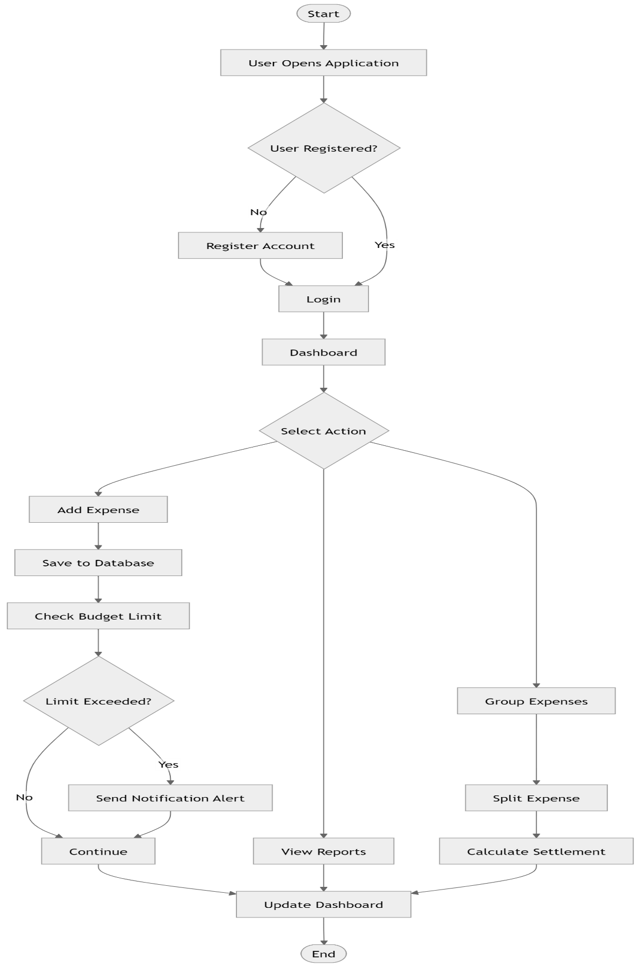
Figure 3:1System Workflow

Requirements of system
For the proper development and execution of the Expentra system, certain hardware and software requirements are necessary. These requirements ensure smooth performance during development, testing, and deployment of the application.
Hardware Requirements
The system can run on standard computing devices with basic configurations. However, better performance can be achieved with higher specifications.
- Processor: Minimum Dual Core 2.0 GHz, Recommended Quad Core 3.0 GHz or higher
- RAM: Minimum 4 GB, Recommended 8 GB or higher
- Storage: Minimum 500 MB free space, Recommended 1 GB or more
- Network: Stable internet connection required for database and notification services
Software Requirements
The development and execution of the system require the following software components:
- Operating System: Windows 10/11, macOS, or Linux
- Node.js: Version 18 or higher
- Package Manager: npm (Node Package Manager)
- Database: MongoDB (local or MongoDB Atlas)
- Web Browser: Google Chrome, Mozilla Firefox, or Microsoft Edge

Modules of the System

Authentication Module
This module handles user registration and login. It uses JWT for secure authentication.
Features:
- User registration
- Login system
- JWT authentication

Expense Management Module
Users can:
- Add expenses
- Edit expenses
- Delete expenses
- Categorize expenses

Budget Management Module
Users can set monthly budgets and receive alerts when limits are reached.
Features:
- Monthly budget setting
- Budget tracking
- Alert generation

Analysis Module
The system analyses user spending patterns and provides insights.
Features:
- Spending analysis
- Monthly comparison
- Prediction of future expenses

Group Expense Module
Users can:
- Create groups
- Add shared expenses
- Split expenses
- Settle debts

Algorithms Used

Debt Settlement Algorithm
This algorithm minimizes the number of transactions between group members.
Steps:
- Calculate net balance of each user
- Identify debtors and creditors
- Match highest debtor with highest creditor
- Repeat until balances are settled

Smart Alert Algorithm
Detects unusual spending behaviour based on daily averages.
Condition:
- If today's expense > 2 × average daily expense

Budget Threshold Logic
- Warning at 80%
- Alert at 100%

Methodology
The project was developed using Agile methodology:
- Requirement analysis
- Design
- Development
- Testing

Testing and Implementation
The system was tested using:
- Unit testing
- API testing using Postman
- Manual testing
Testing ensured that:
- All modules work correctly
- No data inconsistency
- Proper API responses

Challenges Faced
- Handling real-time notifications
- Managing group expense logic
- API integration issues

Database Schema Design
The Expentra system uses MongoDB, a NoSQL database, for storing application data in a flexible and scalable format. The database is structured using multiple collections, each representing a specific entity of the system.
1. User Collection
Stores user authentication and profile details.
- Name
- Email (unique)
- Password (bcrypt encrypted)
- Role (personal/admin)
- Status (active/blocked)
- FCM Tokens (for push notifications)
2. Expense Collection
Stores all personal expense records.
- User ID (reference to user)
- Title (expense name)
- Amount
- Category (auto-detected)
- Date
- Payment Method
- Notes
3. Budget Collection
Stores monthly budget information.
- User ID
- Month and Year
- Limit Amount
- Saving Goal
4. Group Collection
Stores group-related data.
- Group Name
- Created By
- Invite Code
- Members List
5. Group Expense Collection
Stores shared expenses within a group.
- Group ID
- Title
- Amount
- Paid By (multiple users)
- Split Between members
- Settlement Details
6. Notification Collection
Stores all alerts and notifications.
- User ID
- Type (Budget, Smart Alert, etc.)
- Message
- Read/Unread Status
- Reference ID (for deduplication)
7. Income Collection
Stores income records of users.
- User ID
- Amount
- Source
- Date
8. Category Collection
Stores predefined categories with keywords.
- Category Name
- Type (income/expense)
- Keywords (for auto detection)
The database design ensures data normalization, fast retrieval, and scalability for handling large amounts of financial data.

API Design
The backend of Expentra is built using Node.js and Express.js, providing RESTful APIs for communication between frontend and server.
All APIs are prefixed with /api/.
1. Authentication APIs
- POST /api/auth/register → Register user
- POST /api/auth/login → Login user (returns JWT)
- POST /api/auth/google → Google OAuth login
- GET /api/auth/profile → Get user profile
- POST /api/auth/fcm-token → Register device token
2. Expense APIs
- POST /api/expenses → Add expense
- GET /api/expenses → Fetch all expenses
- PUT /api/expenses/ → Update expense
- DELETE /api/expenses/ → Delete expense
3. Budget APIs
- POST /api/budget → Set budget
- GET /api/budget → Get budget status
4. Analysis API
- GET /api/analysis → Get financial insights, predictions, and health score
5. Notification APIs
- GET /api/notifications → Fetch notifications
- PATCH /api/notifications//read → Mark as read
- DELETE /api/notifications/ → Delete notification
6. Group APIs
- POST /api/groups → Create group
- POST /api/groups/join → Join group
- GET /api/groups → Get all groups
7. Group Expense APIs
- POST /api/group-expenses → Add group expense
- GET /api/group-expenses/ → Get group expenses
- GET /api/group-expenses//settlements → Get optimized settlements
8. Income APIs
- POST /api/incomes → Add income
- GET /api/incomes → Fetch income records
These APIs follow REST principles and ensure secure and efficient communication between client and server.

ER Diagram Explanation
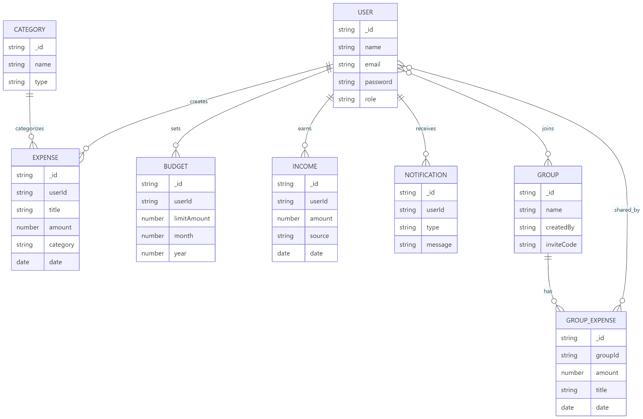
Figure 3:2 ER Digram
The Entity Relationship (ER) diagram represents the logical structure of the database and relationships between different entities.
Main Entities:
- User
- A user can create multiple expenses and budgets.
- A user can belong to multiple groups.
- Expense
- Each expense is linked to a single user.
- Stores details like amount, category, and date.
- Budget
- Each user has one budget per month.
- Used to track spending limits.
- Group
  - A group contains multiple users.
  - Used for managing shared expenses.
- Group Expense
    - Linked to a group.
    - Contains multiple participants (split between members).
- Notification
  - Linked to a user.
  - Stores alerts such as budget warnings and smart alerts.
- Income
  - Linked to a user.
  - Used for financial analysis and reporting.
Relationships:
- One User → Many Expenses
- One User → One Budget (per month)
- Many Users ↔ Many Groups
- One Group → Many Group Expenses
- One User → Many Notifications
The ER model ensures proper data organization and supports efficient querying and data integrity.

Security Implementation
Security is a critical aspect of the Expentra system. Multiple techniques are implemented to ensure data protection and secure communication.
1. Authentication using JWT
- The system uses JSON Web Tokens (JWT) for authentication.
- After login, a token is generated and sent to the client.
- The token is used to access protected APIs.
2. Password Encryption
- User passwords are encrypted using bcrypt hashing.
- Salt rounds are applied to enhance security.
- Plain text passwords are never stored.
3. Authorization Middleware
- Protected routes require a valid JWT token.
- Middleware verifies token before granting access.
- Admin routes are restricted based on user role.
4. Rate Limiting
- API requests are limited (e.g., 2000 requests per 15 minutes).
- Prevents brute-force and DDoS attacks.
5. CORS Security
- Only trusted domains are allowed to access APIs.
- Prevents unauthorized cross-origin requests.
6. Firebase Cloud Messaging Security
- Only registered FCM tokens receive notifications.
- Invalid tokens are automatically removed from the database.
7. Data Validation
- Input data is validated before processing.
- Prevents invalid or malicious data entry.
8. Secure API Communication
- All sensitive operations require authentication.
- Error handling ensures no sensitive data leakage.
These security measures ensure that the system is safe, reliable, and resistant to common web vulnerabilities.

RESULTS AND DISCUSSIONS

Introduction
This chapter presents the results obtained from the implementation of the Expentra system. It includes screenshots of different modules of the application along with detailed explanations of their functionality.
The purpose of this chapter is to demonstrate how the system works in real-time and how different features are implemented successfully.
The developed system successfully performs:
- Expense tracking
- Budget monitoring
- Data analysis
- Notification alerts

User Authentication Module
The authentication module allows users to register and log in securely into the system.
Features:
- User registration with validation
- Secure login using JWT authentication
- Error handling for invalid credentials
The login page allows users to enter their email and password. Upon successful authentication, the user is redirected to the dashboard. If incorrect details are entered, an error message is displayed.

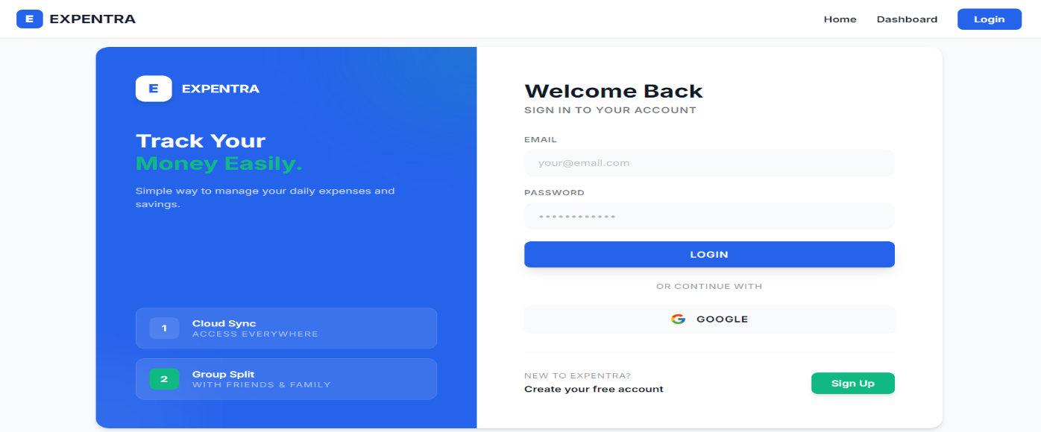
Figure 4:1 Login Page

Dashboard Module
The dashboard provides a summary of user financial activities.
Features:
- Total expenses overview
- Monthly spending summary
- Visual charts and insights
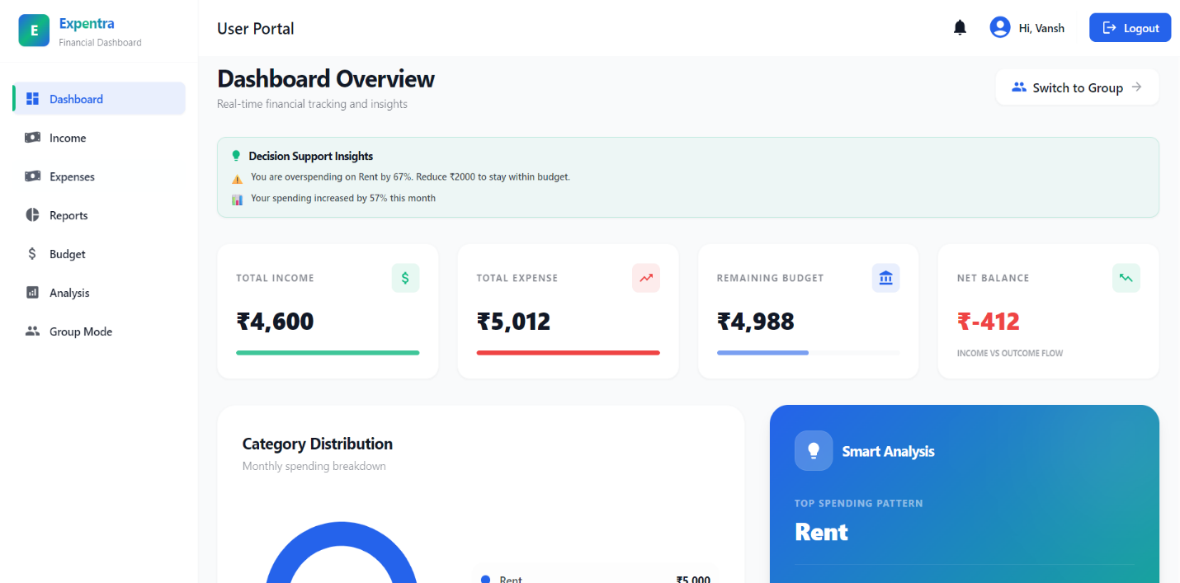
Figure 4:2 Personal Dashboard

Expense Management Module
This module allows users to manage their expenses efficiently.
Features:
- Add new expenses
- Edit and delete existing expenses
- Categorise expenses
Users can add details such as amount, category, date, and description. The system stores this data and updates the total expenses dynamically.
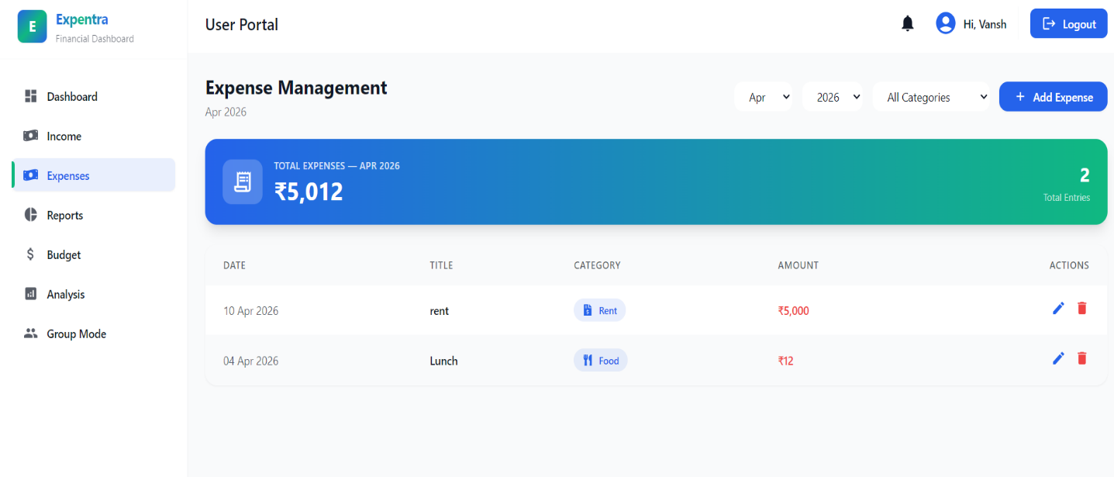
Figure 4:3 Expense Page

Budget Management Module
This module helps users set and monitor their monthly budget.
Features:
- Set budget limit
- Track spending percentage
- Receive alerts on exceeding limits
The budget page shows how much of the budget has been used. When the spending reaches 80%, a warning is shown, and when it exceeds 100%, an alert is triggered.
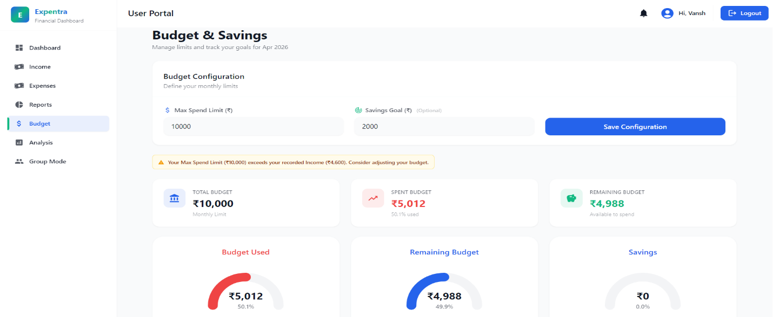
Figure 4:4 Budget Page

Group Selection Module
This page allows users to select or create a group for managing shared expenses.
Features:
- Create new group
- Join existing group
- View list of groups
Users can choose an existing group or create a new one. Once selected, they are redirected to the group dashboard for further actions.
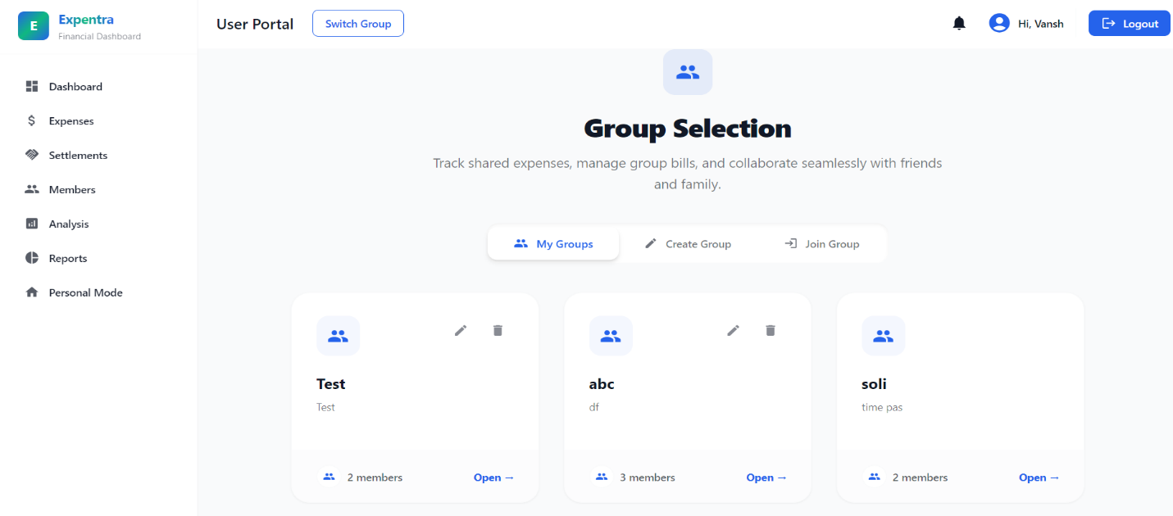
Figure 4:5 Group Selection Page

Group Dashboard Page
This page displays all group-related expense details and activities.
Features:
- View total group expenses
- See recent transactions
- Access group members
The dashboard provides an overview of group expenses and helps users track shared spending efficiently.
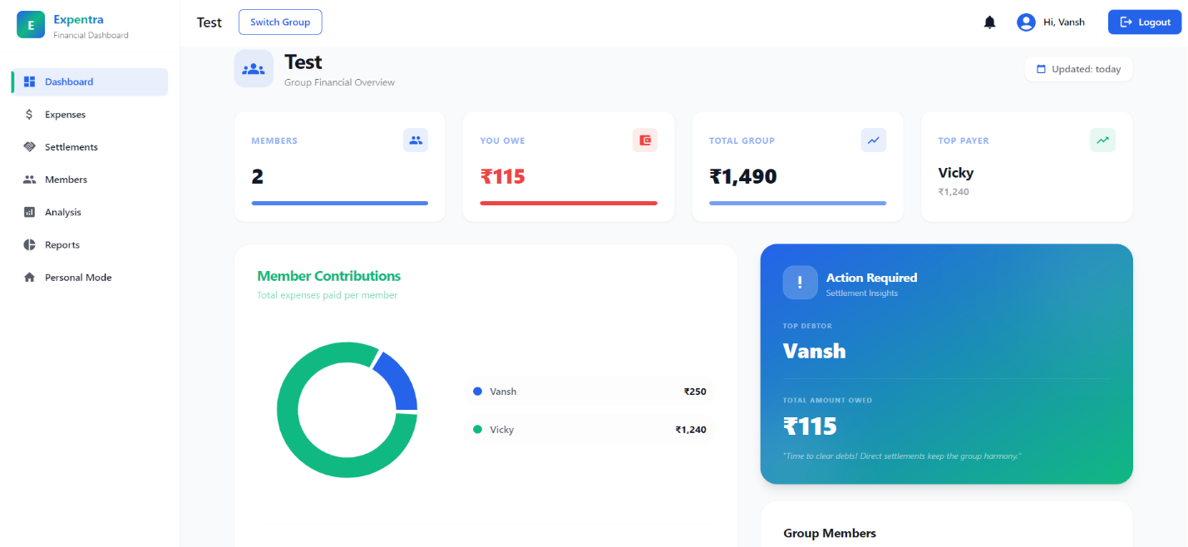
Figure 4:6 Group Dashboard Page

Group Expense Module
This module allows users to manage shared expenses in a group.
Features:
- Create and join groups
- Add group expenses
- Split expenses among members
Users can create groups and add expenses shared among members. The system automatically calculates each member’s share.
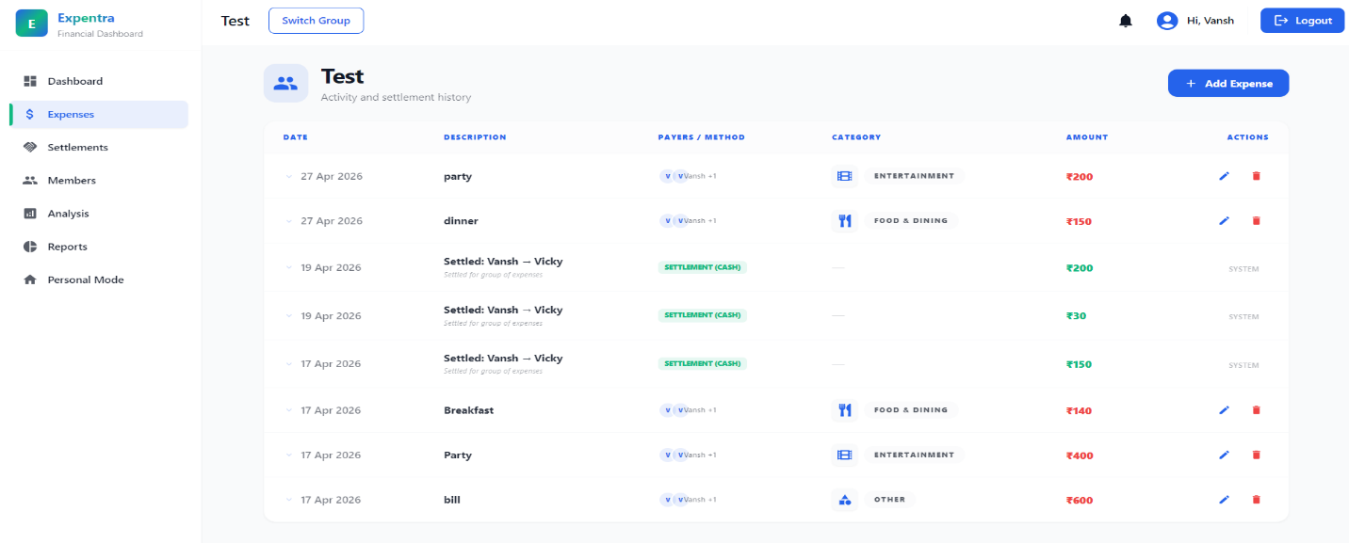
Figure 4:7 Group Expenses Page

Settlement Module
This module simplifies debt settlement between group members.
Features:
- Calculate net balances
- Minimise number of transactions
- Track payment status
The system uses an algorithm to determine who owes money and to whom. It reduces the number of transactions required for settlement.
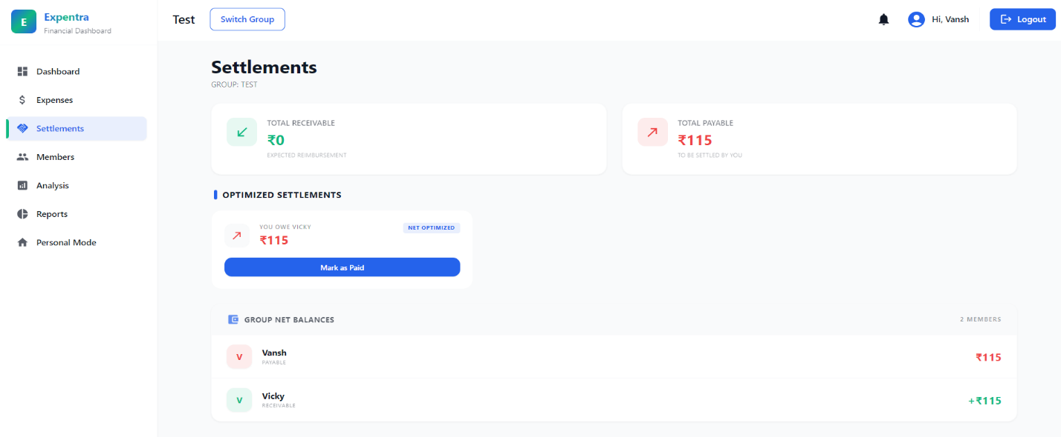
Figure 4:8 Settlement Page

Group Member Manage Page
This page allows management of group members.
Features:
- Add new members
- Remove existing members
- View member list
Users can manage group participants by adding or removing members, ensuring proper expense sharing.
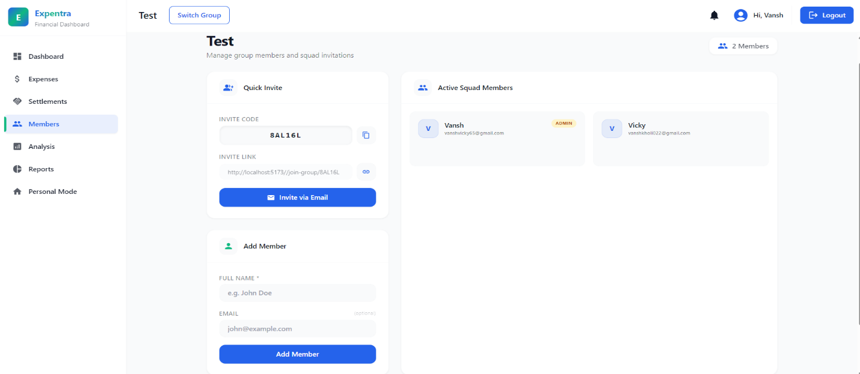
Figure 4:9 Group Member Manage Page

Admin Category Manage Page
This page is used by the admin to manage expense categories.
Features:
- Add new categories
- Edit existing categories
- Delete categories
The admin can control and organise expense categories, which helps users classify their expenses properly.
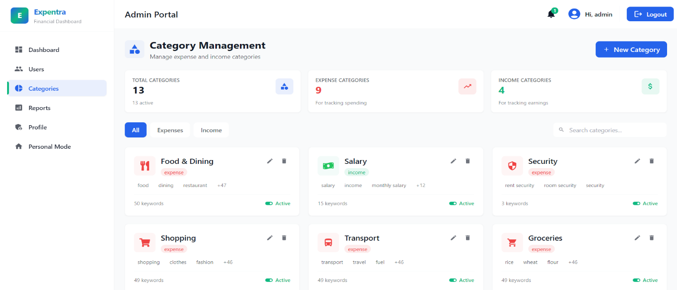
Figure 4:10 Admin Category Manage Page

Testing Results
Testing was performed to ensure that the Expentra system functions correctly, efficiently, and securely. Different types of testing techniques were applied.
1. Unit Testing
Each module of the system was tested independently:
- Authentication module tested for login and registration
- Expense module tested for CRUD operations
- Budget module tested for threshold alerts
- Group module tested for settlement logic
Result: All modules performed as expected without functional errors.
2. API Testing
API testing was conducted using Postman to verify backend functionality.
Tested APIs:
- /api/auth (Login & Register)
- /api/expenses (CRUD operations)
- /api/budget (Budget management)
- /api/analysis (Financial insights)
- /api/group-expenses (Group operations)
Result:
- Correct responses received
- Proper status codes (200, 201, 400, 401)
- Secure authentication using JWT
3. Functional Testing
The complete system workflow was tested:
- User registration → Login → Add expense → Analysis → Alerts
- Group creation → Add expense → Settlement
Result:
- End-to-end flow works correctly
- No data inconsistency observed
4. Smart Alert Testing
Special focus was given to intelligent features:
- Budget alert triggered at 80% and 100%
- Smart alert triggered when spending > 2× average
- Inactivity alert triggered after 24 hours
Result:
- Alerts triggered correctly
- Notifications received successfully
5. UI Testing
User interface was tested for:
- Responsiveness
- Navigation
- User experience
Result:
- Smooth UI performance
- No layout issues
6. Security Testing
- JWT authentication tested
- Unauthorized API access blocked
- Password encryption verified
Result:
- System is secure against unauthorized access
Overall, testing confirmed that the Expentra system is reliable, efficient, and ready for real-world usage.

Advantages
- Easy and user-friendly interface
- Real-time tracking and updates
- Smart alerts and notifications
- Efficient group expense management

Limitations
- Requires internet connectivity
- Depends on user input accuracy
- Limited integration with external financial systems

CONCLUSION & FUTURE SCOPE

Conclusion
The “Expentra – Expense Management System” project successfully demonstrates the development of a modern web-based application for managing personal and group expenses. The system effectively addresses the limitations of traditional expense tracking methods by providing an automated, user-friendly, and intelligent solution.
Through this project, various functionalities such as expense tracking, budget monitoring, data analysis, and group expense management have been successfully implemented. The integration of real-time notifications and smart alert mechanisms enhances the usability of the system and helps users maintain better control over their financial activities.
The project also showcases the practical implementation of full-stack development using the MERN stack, including frontend development with React.js, backend API development with Node.js and Express.js, and database management using MongoDB. Additionally, Firebase Cloud Messaging has been used to enable real-time notifications, making the system more interactive and responsive.
Overall, the system provides an efficient platform for financial management and helps users make informed decisions based on their spending behaviour. The project has contributed significantly to understanding real-world application development, system design, and problem-solving techniques.

Future Scope
Although the system performs efficiently, there are several areas where it can be further enhanced to improve its functionality and usability.
The future scope of the project includes:
- Integration with banking and payment systems for automatic expense tracking
- Implementation of Artificial Intelligence for personalised financial recommendations
- OCR-based receipt scanning for automatic data entry
- Development of a mobile application for better accessibility
- Support for multi-currency transactions for global users
- Advanced data visualisation and reporting features
These improvements can make the system more powerful, user-friendly, and suitable for real-world large-scale applications.

REFERENCES
- React Documentation, https://react.dev
- Node.js Documentation, https://nodejs.org
- MongoDB Documentation, https://mongodb.com
- Firebase Documentation, https://firebase.google.com
- GitHub Documentation, https://github.com
- Vercel Documentation, https://vercel.com
- Render Documentation, https://render.com
- Postman Documentation, https://postman.com
- JSON Web Token (JWT), https://jwt.io
- Tailwind CSS Documentation, https://tailwindcss.com

APPENDIX
A. SAMPLE API CODE
The following code represents the implementation of expense creation API in the Expentra system. This API not only stores expense data but also triggers budget alerts and smart anomaly detection.
// Create Expense API
export const createExpense = async (req, res) => {
const { title, amount, date } = req.body;

// Create new expense
const expense = await Expense.create({
userId: req.user._id,
title,
amount,
date,
});

// Budget overflow check (async)
checkAndNotifyBudgetOverflow(req.user._id);

// Smart alert logic
const avgDaily = await calculateDailyAverage(req.user._id);
const todaysTotal = await calculateTodayTotal(req.user._id);

if (avgDaily > 0 && todaysTotal > avgDaily * 2) {
sendPushNotification(req.user.fcmTokens, {
title: "Smart Alert",
body: "Unusual high spending detected today.",
data: { route: "/expenses" },
});
}
res.status(201).json(expense);
};
This API demonstrates:
- Expense creation
- Budget monitoring
- Smart alert generation
- Real-time notification triggering
B. SAMPLE JSON RESPONSE
The following is a sample JSON response returned by the system when an expense is successfully created.
{
"_id": "6612ab34cd5678ef90123456",
"userId": "6601bc23de4567fa89012345",
"title": "Food Expense",
"amount": 500,
"category": "Food",
"date": "2025-02-10T00:00:00.000Z",
"paymentMethod": "upi",
"createdAt": "2025-02-10T10:15:30.000Z",
"updatedAt": "2025-02-10T10:15:30.000Z"
}
Sample Analysis API Response:
{
"monthlyGrowthPercentage": 12.5,
"predictedExpense": 15000,
"averageDailyExpense": 500,
"financialHealthScore": 85,
"topCategory": "Food"
}
These responses are used by the frontend to render dashboards, charts, and insights.
C. Tools Used
Frontend: React.js, Vite, Tailwind CSS, Recharts, React Toastify
Backend: Node.js, Express.js, JWT, bcrypt
Database: MongoDB Atlas, Mongoose
Notifications: Firebase Cloud Messaging (FCM)
Development Tools: Visual Studio Code, Postman, Git, GitHub
Additional Tools: html2pdf.js, Axios, Firebase SDK

